**Course End Project- Crime Analysis**

**Scenario:**

Crime analysis is important for law-and-order maintenance at any place. It helps the police department and law enforcement agencies to identify patterns of crime, which is crucial for the effective planning of a crime prevention program. You are a data analyst in the research wing of the police department, and you are reached out to help the department analyze the data of past criminal activities. The purpose of crime data analysis is to support the operations of the police department, like criminal investigation, apprehension, prosecution, and development of crime prevention and reduction strategies.

**Task:**

As a data analyst, to keep the police department and the city updated on the statistics of crime events, you are tasked to create a dashboard or story using Tableau for the communication website and pay attention to data storytelling.

**Result:**

We are going to create dashboards that help the crime department to analyse the crimes taking place throughout various places and help the department in criminal investigation, apprehension, prosecution, and development of crime prevention and reduction strategies.

Overall Crime Statistics Dashboard**:**

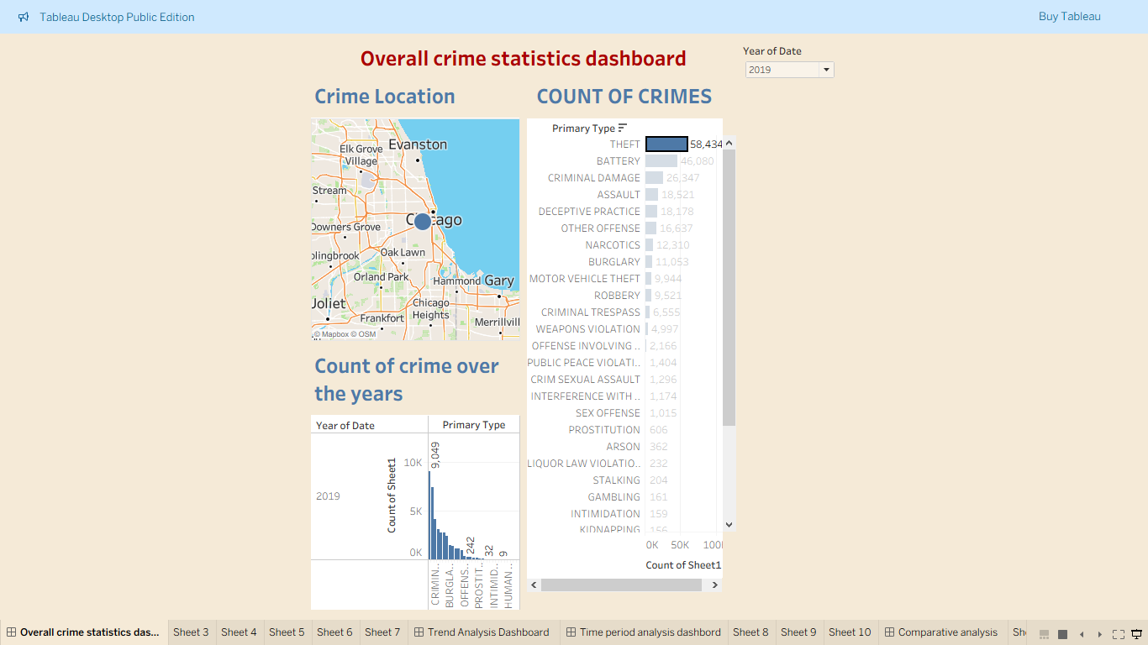

Analysis:

This dashboard shows the overall crime statistics. We are able to see that ‘Theft’ has been reported very often and it’s the crime that’s taking place very commonly.

Time Period Analysis Dashboard:

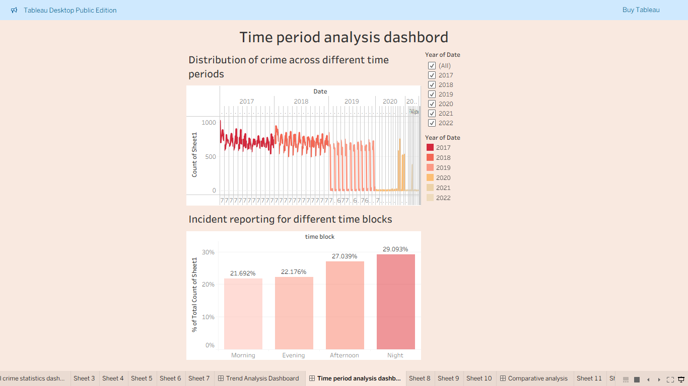

Analysis:

This dashboard shows the crime rates across different time periods. We can see that most crimes have been reported during afternoon and in the nights. The police force have to tighten the security and protection more during these times. Also, the crimes rates have reduced very much in the last few years. In 2022, the crime rate has been very less. The initial 4-5 days of every month, the crimes reported have been on the higher side.

Trend Analysis Dashboard:

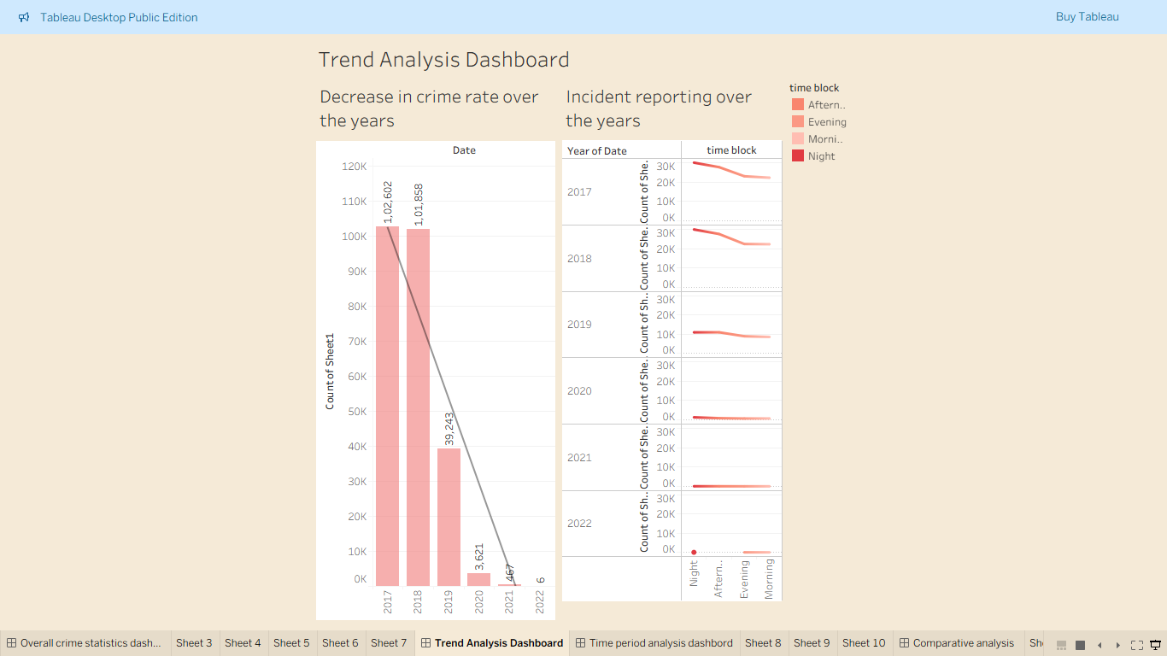

Analysis:

After analysis we can find that over the years the crime rate has decreased drastically. It shows downward trend line indicating decrease in crime rates. It shows that the police department’s measures and security in the last few years has been very good. They just need to continue the same to maintain this record.

Comparative Analysis:

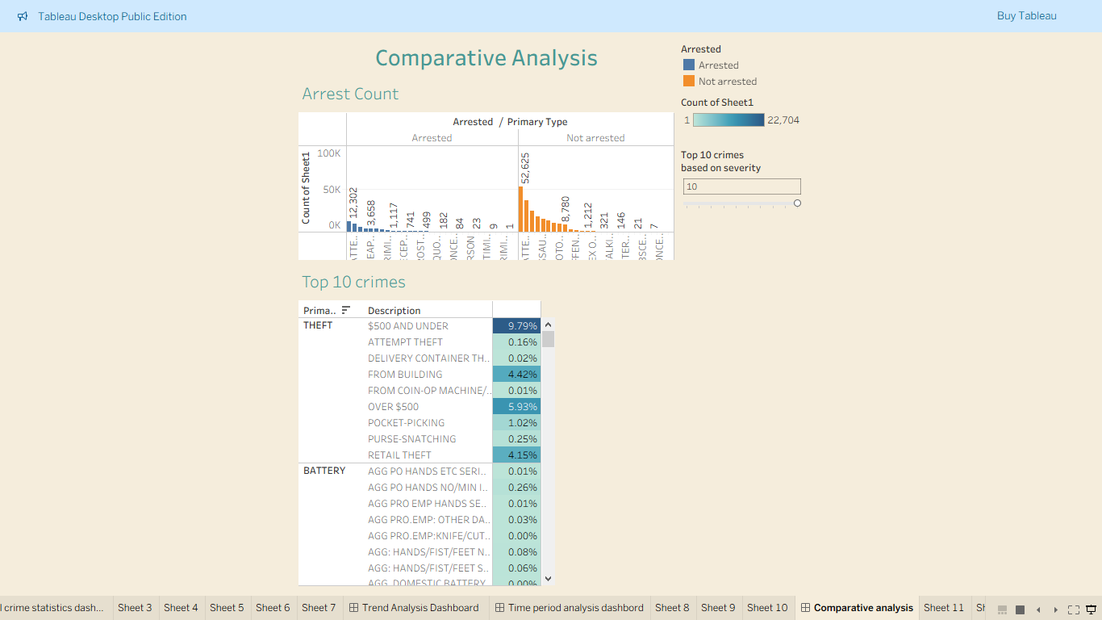

Analysis:

We can clearly see that there has been less number of arrests and large number of ‘not arrested’ cases. ‘Theft’ is the most severe and popular crime reported across the city. Under theft the category ‘$500 and under’ is the most reported one. All cases registered under “Narcotics” have been arrested. It can also be considered has the most dangerous one where an arrest is assured.